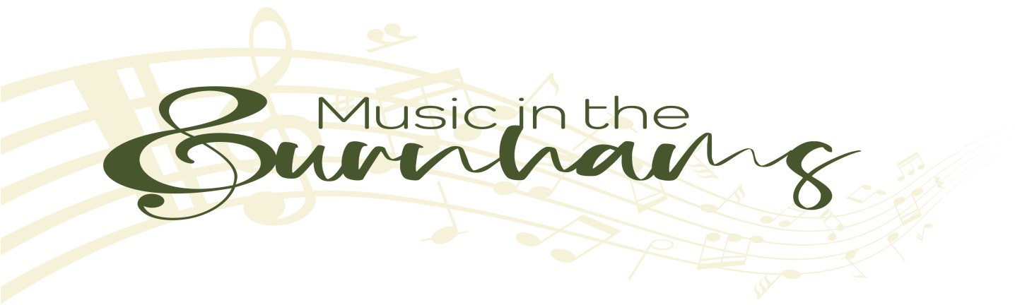

The Friends of Music in the Burnhams

The Friends of Music in the Burnhams is a group of enthusiastic people who love music and actively support Music in the Burnhams by becoming a “Friend”.

Friends have

* Reserved seats
* Invitations to special Friends’ recitals and receptions
* Priority booking

By becoming a Friend you help support the ongoing costs of promoting and providing musical events in the Burnham area. In addition, your valued support is vital to the continued success of Music in the Burnhams.

Annual membership is £50 per person and your membership runs for an entire calendar year. Payment can be made by cheque, a bank transfer or by setting up a standing order with your bank.

Our bank details are;

Name: **Music in the Burnhams**

Sort code: **08-92-99**

Account No: **67345397**

Please complete the form overleaf and return by email to [thorpemusic2021@gmail.com](mailto:thorpemusic2021@gmail.com)

or by post to:

**Friends of Music in the Burnhams**

**48 King Street King’s Lynn PE30 1HE**

|  |  |
| --- | --- |
| Title | First Name: |
|  | Last Name: |
| Address | Postcode: |
| Tel / Mobile |  |
| Email |  |

🞎 I confirm that I am happy to be included on the mailing list of Music in the Burnhams in order to be kept up to date with all concerts and other events.

Please see our Privacy Policy on our website <https://musicintheburnhams.com/privacy/>

**Charity Gift Aid Declaration**

|  |
| --- |
| **Boost your donation by 25p of Gift Aid for every £1 you donate**  Gift Aid is reclaimed by Music in the Burnhams from the tax you pay for the current year. Your address is needed to identify you as a current UK taxpayer.  **In order to Gift Aid your donation you must tick one of the boxes below:** |

🞎 I want to Gift Aid my donation of £___________ to Music in the Burnhams

🞎 I want to Gift Aid my donation of £___________ and any other donations I make in the future or have made in the past 4 years to Music in the Burnhams

I am a UK taxpayer and understand that if I pay less Income Tax and/or Capital Gains Tax in the current tax year than the amount of Gift Aid claimed on all my donations, it is my responsibility to pay the difference.

Please contact Music in the Burnhams by email or post (contact details given above) if you:

* Want to cancel this declaration
* Change your name or home address
* No longer pay sufficient tax on your income and/or capital gains

If you pay Income Tax at the higher or additional rate and want to receive the additional tax relief due to you, you must include all your Gift Aid donations on your Self Assessment tax return or ask HM Revenue and Customs to adjust your tax code.

Signed:

Date: